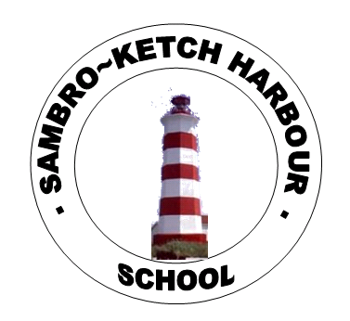   |  | December 2024
Sunday | Monday | Tuesday | Wednesday | Thursday | Friday | Saturday
1 | 2 | 3 | 4 | 5 | 6 | 7
 |  | International Day of Persons with Disabilities | Hot lunch order closes at noon  Progress Conferences  5:30-7:30 PM | No School  Progress Conferences  1:00-3:00 pm
8 | 9 | 10  International Human Rights Day | 11 | 12 | 13  Hot | 14
 |  | International Human Rights Day |  |  | Hot lunch ordering starts
15 | 16  Tick | 17 | 18 | 19 | 20 | 21
 | Ticket draw for holiday brunch  Holiday/winter  Hair or hat day | Wear your brightest clothes and accessories to celebrate Sambro | Hot lunch ordering closes at noon  Holiday brunch  School Bingo | Bring in a board game or book day! | School sing-a-long  Cozy/comfy day
22 | 23 | 24 | 25 | 26 | 27 | 28
 |  |  | Christmas Day  First day of Hanukkah | Kwanzaa | Hot lunch ordering starts
29 | 30 | 31 | 1 | 2 | 3
 |  |  | Hot lunch ordering closes at noon |  | First day back for students

